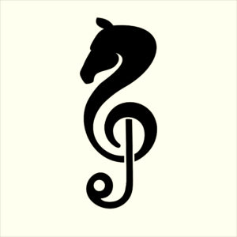

INFORMATION FOR WALK FREESTYLE DRESSAGE TO MUSIC CLASSES
Information from British Dressage can be found by clicking: Freestyle Dressage to Music

TIME ALLOWED:
Minimum of 4 1/2 minutes maximum of 5 minutes

MUSIC:
Remember you are responsible for ensuring you have the right to use any music included with your test. Dressage Addict take no responsibility or accept any liability for any breach of copyright laws.

WALK LEVEL COMPULSORY MOVEMENTS FOR TECHNICAL MARKS:
- 1/2 10m half circle to the left in medium walk
- 1/2 10m half circle to the right in medium walk
- Free walk on a long rein (minimum 20m)
- 3 loop serpentine
- 20m circle left
- 20m circle right
- Fluency of transitions
- Entry and halt at the start and the halt at the end

NON-COMPULSORY MOVEMENTS:
- Circles and half circles of any size
- Give and retake the reins
- Lateral Movements

PROHIBITED MOVEMENTS:
- Trot
- Canter
- Rein back
- Reins in one hand
- Walk pirouettes/half pirouettes Piaffe

